|  |  |
| --- | --- |
| Date |  |
| Team ID | LTVIP2025TMID38625 |
| Project Name | Revolutionizing Liver Care |
| Maximum Marks | 4 Marks |

**Technical Architecture:**

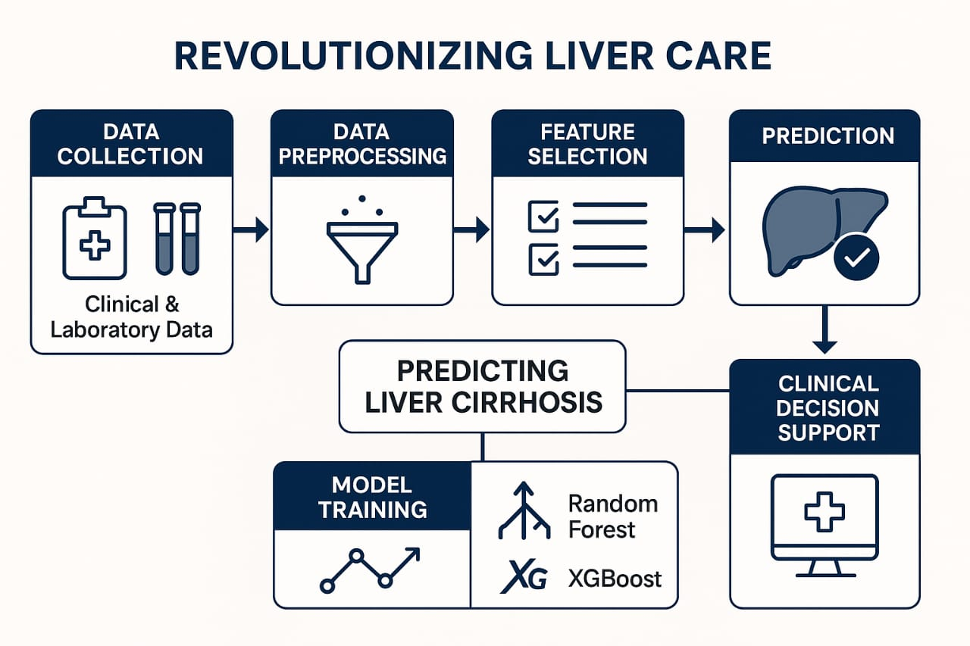

**Table :1**

|  |  |  |
| --- | --- | --- |
| **Guideline Category** | **Description** | **Reference / Standard** |
| **Total Product Lifecycle (TPLC)** | Design, development, deployment, and post-market monitoring built into the process. Includes risk planning, performance checks, and regulatory submissions. | FDA draft guidance [fda.gov+13digitalhealthglobal.com+13gtlaw.com+13](https://www.digitalhealthglobal.com/fda-issues-draft-guidance-for-ai-enabled-medical-devices-key-recommendations-and-updates/?utm_source=chatgpt.com) |
| **Device & Data Description** | Document inputs (labs, images, histology), outputs (risk scores, heatmaps), intended users & environments in device description and model “card”. | FDA draft , FUTURE-AI |
| **Data Management & Bias Mitigation** | Ensure high-quality, diverse, labeled, and segregated training/validation sets. Document data provenance, harmonization, and annotate edge cases. Bias mitigation via subgroup analysis. | FDA draft , FUTURE-AI |
| **Model Documentation** | Detail algorithm architecture, features, hyperparameters, threshold selection, and ensemble techniques. Provide explainability tools (SHAP, Grad‑CAM). | FDA draft , FUTURE-AI |
| **Validation & Usability** | Perform rigorous validation using real-world data. Include human factors and usability testing for clinicians. Report metrics like AUROC, sensitivity, and segmentation performance. | FDA draft |
| **Risk Management** | Maintain an ISO 14971-compliant risk file, factoring in hazards across entire system lifecycle. Include cybersecurity, failure modes, and mitigation strategies. | FDA draft |
| **Cybersecurity & Integrity** | Safeguard against threats like data poisoning, inversion, and drift. Implement encryption, authentication, patching, and monitoring systems. | FDA draft |
| **Post-Market Performance Monitoring (PMPM)** | Track real-world performance, detect drift, and update via pre-approved Predetermined Change Control Plan (PCCP). Include real-time monitoring and safety checks. | FDA draft |
| **Transparency & Labeling** | Provide comprehensive labeling and model cards: AI usage, limitations, performance across demographics, versioning, and update protocols. | FDA draft |
| **Governance & Standards** | Adhere to IEC 62304, ISO 14971, leverage design controls (21 CFR 820.30), and maintain records per ISO 13485. Ensure traceability and design history documentation. | IEC/ISO standards |
| **Trustworthy AI Principles** | Embed fairness, universality, traceability, usability, robustness, and explainability—FUTURE‑AI consensus framework—to promote trust in clinical deployment. | FUTURE-AI |

**Table :2**

|  |  |  |
| --- | --- | --- |
| **Component** | **Description** | **Technology / Standard** |
| ("Ingestion API", "Secure endpoint for EMR, DICOM, histology, omics", "REST, gRPC, TLS/AES‑256") | Accepts structured and unstructured inputs, ensures encrypted transport. |  |
| ("Storage", "Encrypted storage for structured and image data", "SQL/NoSQL, Object Store, AES‑256") | Stores lab/clinical records, images, WSIs with security at rest. |  |
| ("Preprocessing", "Data cleaning, normalization, image segmentation & radiomics extraction", "Pandas/sklearn, MONAI, U‑Net, TransUNet") | Prepares raw data for model input. |  |
| ("Feature Store", "Central repository for processed features", "Feast, Azure Feature Store") | Ensures consistent feature retrieval during train and serve. |  |
| ("Model Training", "Train ML/DL models and ensembles", "scikit‑learn, LightGBM, XGBoost, PyTorch/TensorFlow") | Core modeling layer for risk prediction. |  |
| ("Explainability", "Generate feature importance & visual heatmaps", "SHAP/LIME, Grad‑CAM") | Provides interpretability for clinician review. |  |
| ("Validation", "Cross-validation, benchmark metrics, external testing", "sklearn cv, AUROC, Dice, calibration") | Ensures model performance and generalization. |  |
| ("Inference Service", "Expose real-time risk prediction API", "Docker/K8s, REST/gRPC, <500 ms latency") | Enables clinical-grade, fast risk assessments. |  |
| ("Dashboard UI", "Visual interface for data input, results & explanations", "React/Vue, medical image viewer") | Clinician-facing interface with usability features. |  |
| ("EMR/PACS Integration", "Seamless embedding into hospital workflows", "FHIR, DICOM, HL‑7, IHE XDS.b") | Ensures interoperability and automated data flow [chat2db.ai+6ncbi.nlm.nih.gov+6aalpha.net+6](https://www.ncbi.nlm.nih.gov/books/NBK602594/?utm_source=chatgpt.com)[aalpha.net](https://www.aalpha.net/blog/how-to-build-ai-agent-for-healthcare/?utm_source=chatgpt.com). |  |
| ("Monitoring & Ops", "Track performance & trigger retraining", "Prometheus, Grafana, CI/CD, drift detection") | Operational reliability with alerting and metrics. |  |
| ("Security & Compliance", "End-to-end protection and audit logging", "RBAC, GDPR/HIPAA, ISO 13485, audit trails") | Meets regulatory and privacy requirements. |  |
| ("Model Registry", "Versioning, lineage, reproducibility", "MLflow, DVC, Model cards") | Controls model lifecycle and traceability. |  |